**Adaptating productivity functions for in Heureka for Norwegian conditions**

1. Normal CTL operations (Harvester / Forwarder)

In order to update productivity functions to better reflect the differences between Norwegian and Swedish forestry conditions, we calibrated the standard functions in Heureka (Brunberg) using data from a large contractor ( 3 harvesters, 3 forwarders) operating in the Valdress area, i.e. relatively steep terrain with low volumes per ha. The contractor uses only Komatsu machines, and all data is transmitted and stored in a propriety database system known as Maxifleet. Only clearfelling operations were considered as the data available for thinning operations in Norway are too sparse to base any adaptions on.

For comparative purposes, stands were visited by colleagues from Skogkurs and visually assessed for surface unevenness and slope – two of the most important factors influencing maneuverability. Also, percentage of difficult trees, extent of undergrowth, and general operating conditions were assessed in order to be able to align the predictions with actual harvesting productivity rates as closely as possible.

The post-harvest machine data was extracted from the Maxifleet system and analysed for around 30 stands that had complete data. This process involved adjusting Brunberg’s functions until they showed a good fit with the actual machine productivity. The biggest source of error is likely to be in the estimate of stand area, which influences stocking densities. Stocking is related to driving times for both the harvester and forwarder. The revisions recommended for adapting the existing Brunberg functions are discussed separately for Harvesting and Forwarding below.

* 1. Harvesting

Total effective harvesting time is divided into driving time and processing time. No changes were made to the driving component (t1). In regressing Brunberg’s predictions against the actual productivities observed, it was found that both the intercept and the slope in routine t2 (HarvesterClearcutFellProcessTime_SkogForsk)had to be adjusted. The intercept was adjusted downwards by 6 units and the slope increased by a factor 2.82, and the new equation for processing time (t2) is given below.



The new intercept and steeper slope is partly explained by the fact that the original Brunberg functions represented tree sizes of up to 2m3 each, and this span didn’t reflect the dynamics of the rapidly increasing productivity in small trees correctly. The function should not be extrapolated beyond tree sizes of 1 m3.Also, the forests in the control dataset probably represent some of the more marginal trees in Norway – low volumes per hectare, poorer form and higher branchiness than trees in the lower lying areas. Nonetheless, productivity predicted here is considered low, about 18m3 per productive machine hour for trees of 0.3 m3 against an expected productivity of roughly 25 m3 per hour.

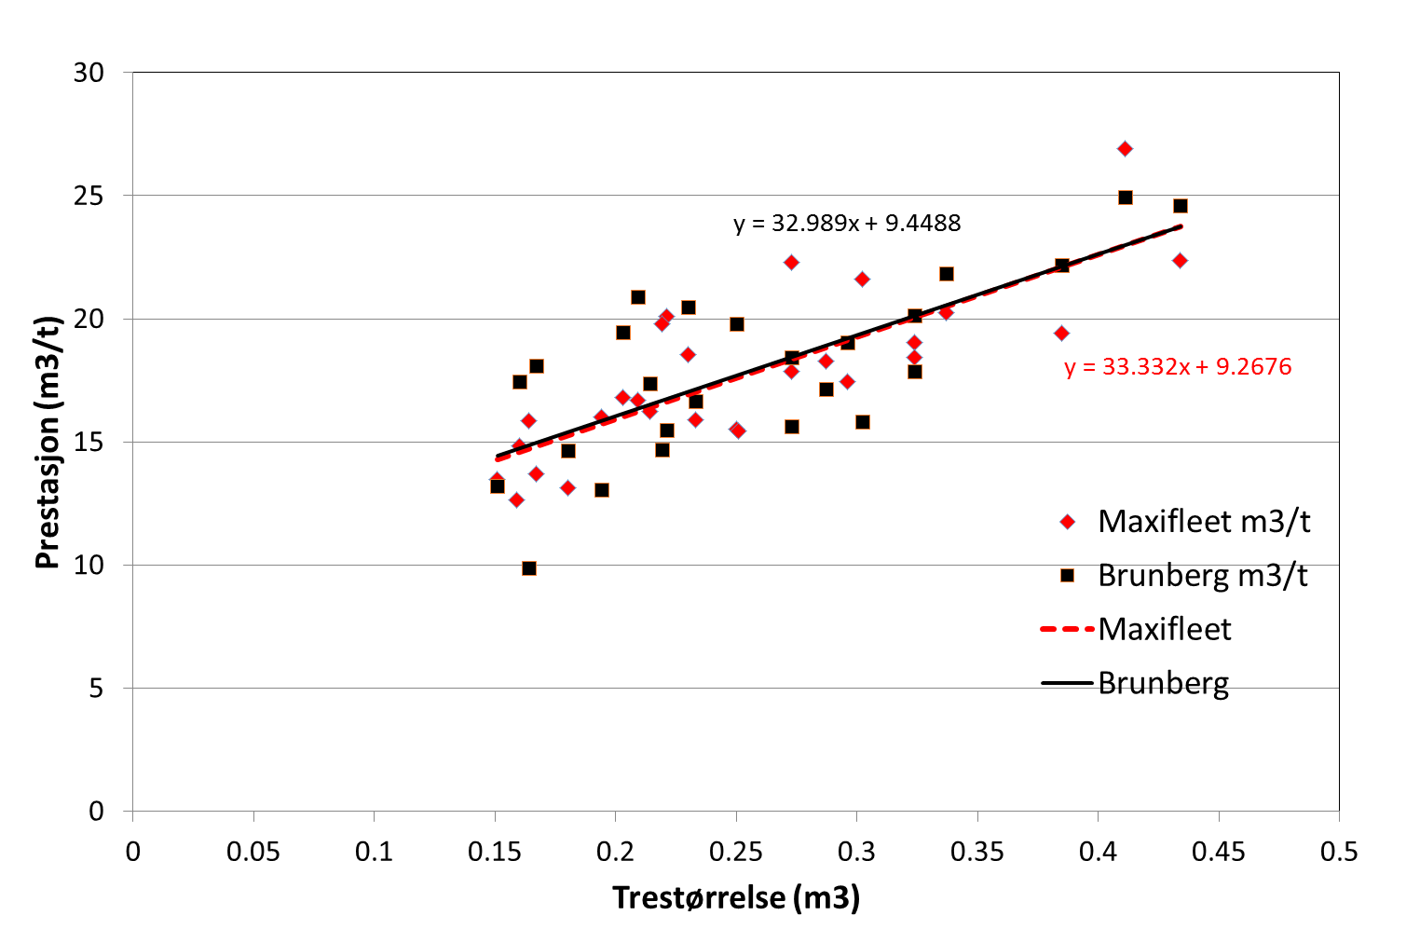

Figure 1 Final adjustment of Brunberg predicted performance levels (black squares) to actual performance found in the Maxifleet database (red diamonds) – units in m3/productive machine hour (G0)

1.2 Forwarding

Forwarder operations are largely divided into terminal time (loading, loading while driving, and unloading) and driving time (driving into and out of the stand). Terminal time depends largely on the volume per ha (influenced by the uncertain stand sizes in the control data), and the number of assortments (high assortment number increases loading and unloading (sorting) times). Driving while loading is influenced by the concentration of assortments, so is also dependent on both.

Brunberg models driving speed as a function of surface unevenness and slope, both measured in categories of 1-5, where 5 represents the worst conditions. The combination of these greatly influences driving speed (Figure 2). This again has a greater or smaller effect on time consumption and overall productivity, depending on the extraction distance.

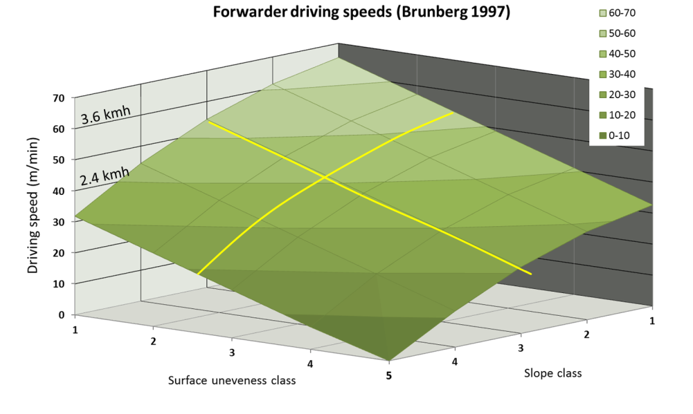

Figure 2 Forwarder driving speed (m/min) as a function of surface unevenness and slope.

The only change required to Brunberg’s forwarding model was to factor K1 in routine: ForwarderTerminalTime_SkogForsk (t4) from the original value of 1 to K1=1.4, which allowed for a good fit with the field data.

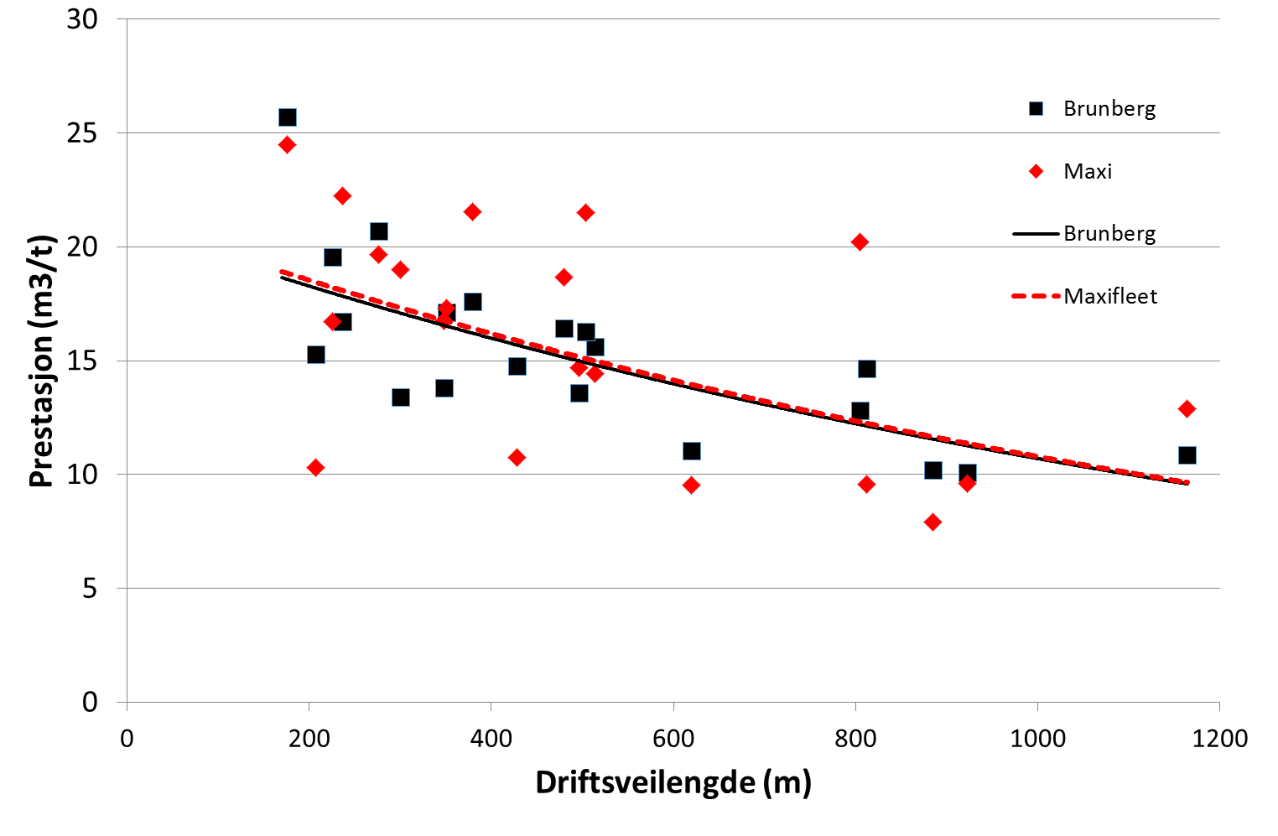

Figure 3 Forwarder productivity against extraction distance (productivity figures in m3 per G15 hr)

The existing parameters used in modeling the effect of surface unevenness and slope on driving speed appear to perform correctly, also in the more extreme terrain present in the dataset.